PROTOTYPE EXTENSION:
User interface design of the extended Smart Safety companion prototype using MIT app inventor
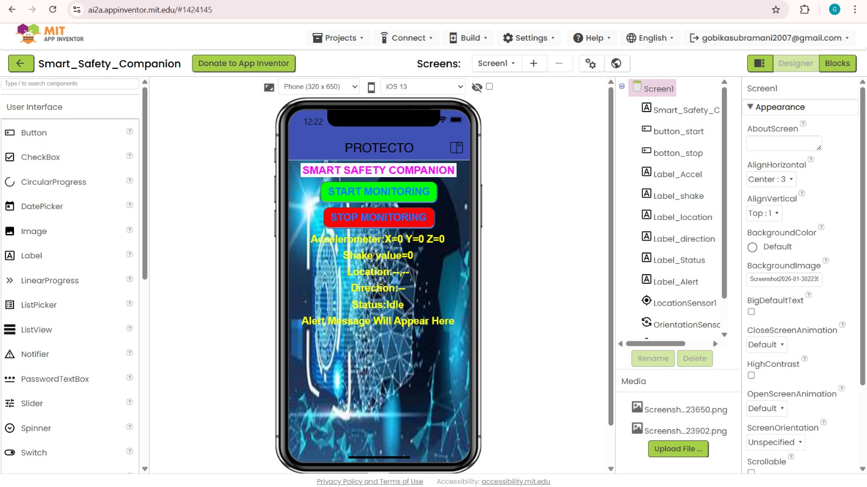

The screenshot shows the MIT App Inventor design environment for an app named smart_safety_companion.
Main UI Components:
- Title Label:
“SMART SAFETY COMPANION” displayed prominently for clear identification.
- Control Buttons:
  - START MONITORING (Green):
  - STOP MONITORING (Red): Stops all monitoring activities.
- Sensor Data Display Labels:
  - Accelerometer Values: Shows X, Y, and Z axis readings.
o Shake Value: Indicates motion intensity detected by the accelerometer.
  - Location: Displays the current GPS position.
  - Direction: Shows device orientation or movement direction. o Status: Displays the current system state (e.g., Idle).
  - Alert Message: Area to show emergency alert notifications.
Sensors Used
- Accelerometer Sensor: Detects movement and shake events.
- Location Sensor: Fetches real-time geographic location.
- Orientation Sensor: Identifies device direction.
- Clock Component: Used for timing, delays, or periodic checks.
Designer Panels
- Left Panel (Palette):
Contains user interface components such as Buttons, Labels, Images, and Sensors that can be dragged into the screen.
- Right Panel (Components & Properties):
Lists all components used in Screen1 (Buttons, Labels, Sensors) and allows modification of properties like font size, text color, alignment, visibility, height, and width.

Block – level implementation of accelerometer, location and alert logic in the extended prototype
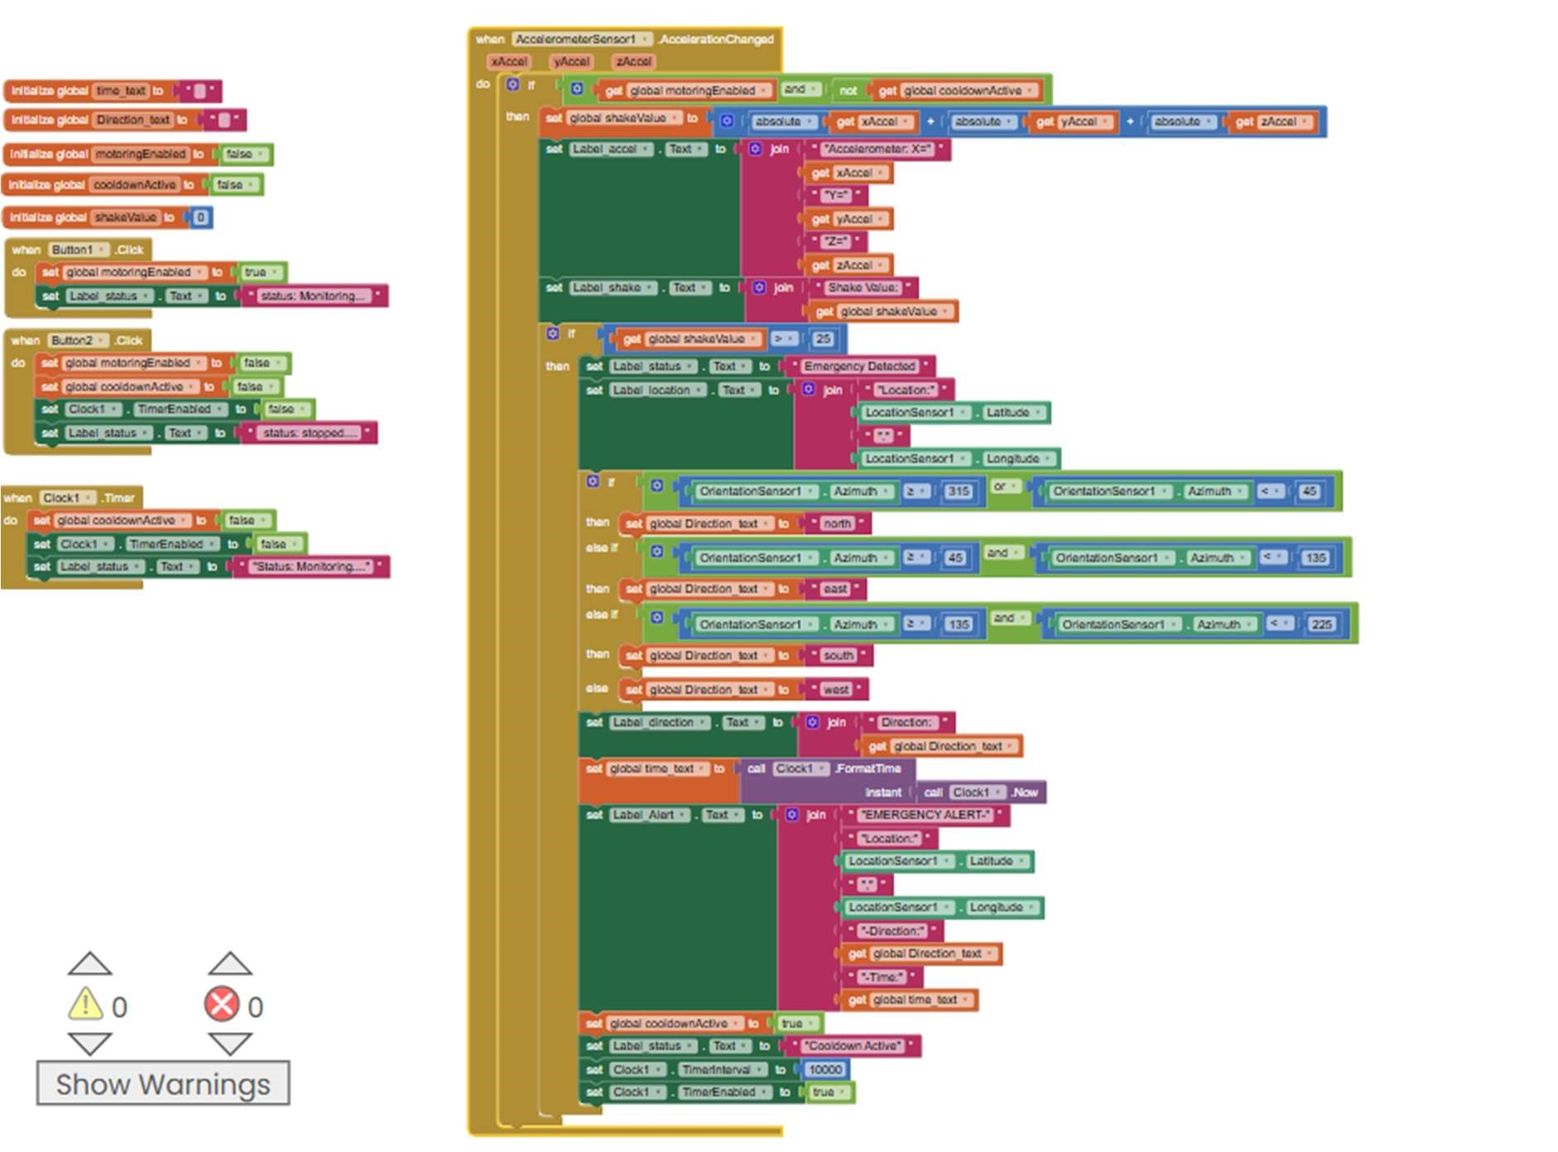

The MIT App Inventor blocks implement a safety‑alert app that:
1.Start Monitoring button enables sensor monitoring and updates the status.
- Stop Monitoring button disables monitoring and stops the timer.
- Accelerometer reads X, Y, Z values and calculates shake intensity.
- .If shake value exceeds the threshold, an emergency is detected.
- Location sensor fetches latitude and longitude.
6.Orientation sensor identifies direction (North, East, South, West).
- Clock captures the current time for alert details.
- Alert message displays location, direction, and time.
- Cooldown timer prevents repeated emergency alerts.

Output screen of Smart Safety Companion showing emergency detection and real-time sensor data:
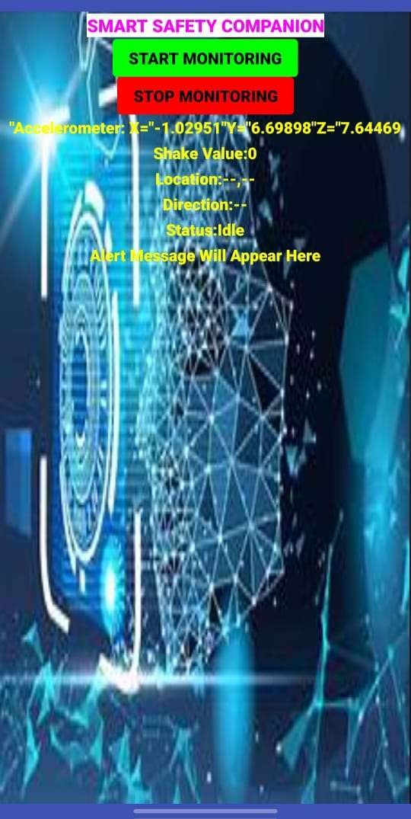

Purpose of the Application:
The Smart Safety Companion app is intended to:
- Continuously monitor user movement.
- Detect abnormal shaking or motion.
- Track user location.
- Display real-time sensor data.
- Trigger alerts during emergency situations.
- Provide manual control using Start and Stop buttons.

Conclusion:
The Smart Safety Companion application effectively uses mobile sensors to detect emergency situations and provide timely safety alerts. By capturing movement, location, and time details, the app enhances personal security in a simple and user-friendly manner. This project demonstrates the practical use of sensor-based technology for real-world safety applications.

